**SAVEETHA SCHOOL OF ENGINEERING**

**SAVEETHA INSTITUTE OF MEDICAL AND TECHNICAL SCIENCES**

**INSTITUTE OF PLACEMENT AND TRAINING**

**CSA0987 –JAVA PROGRAMMING**

**NAME : M.MEGHANADH**

**REG.NO:192325026**

**ASSIGNMENT:2**

1. Write a program for matrix multiplication?

Sample Input:

Mat1 = 1 2

5 3

Mat2 = 2 3

4 1

Sample Output:

Mat Sum = 10 5

22 18

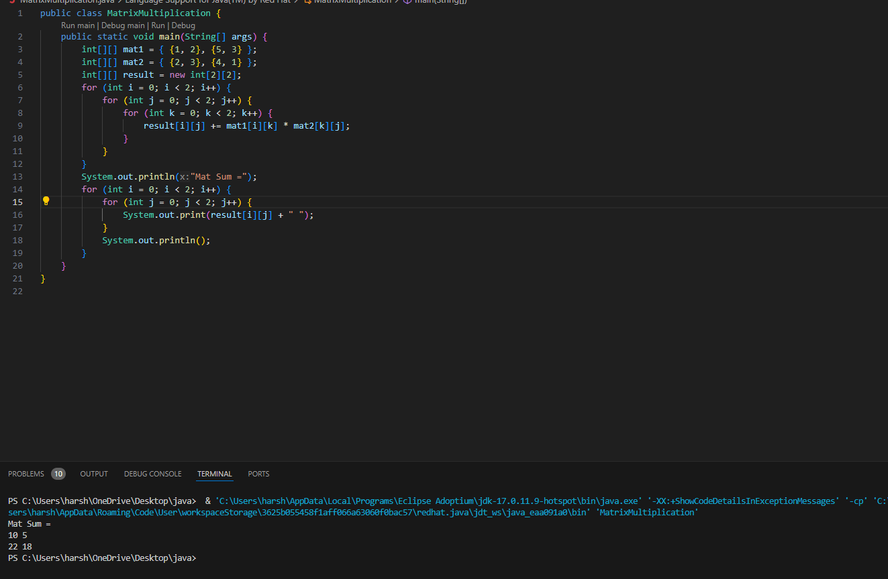

1. Write a program for matrix addition?

Sample Input:

Mat1 = 1 2

5 3

Mat2 = 2 3

4 1

Sample Output:

Mat Sum = 3 5

9 4

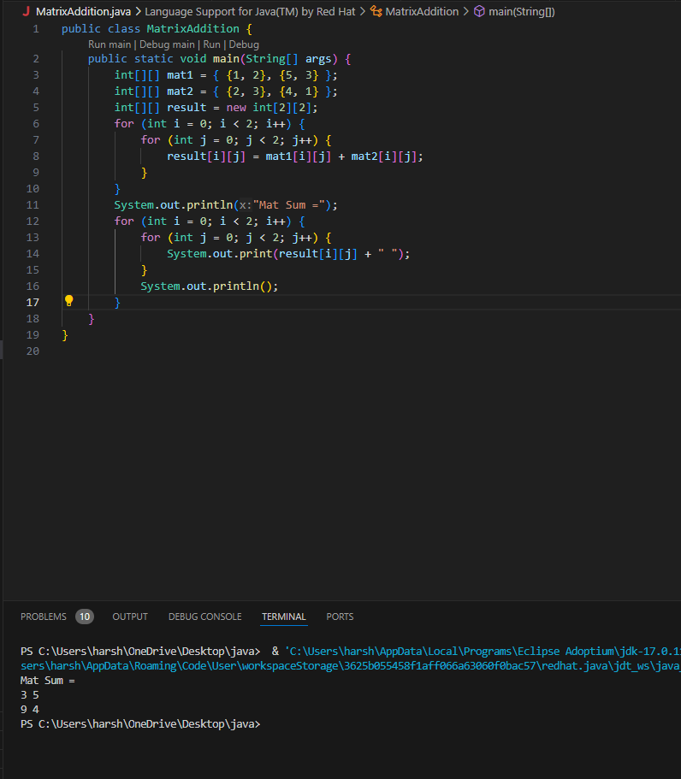

1. Write a program for Merge two sorted arrays using Array list

Input: arr1[] = { 1, 3, 4, 5}, arr2[] = {2, 4, 6, 8}

Output: arr3[] = {1, 2, 3, 4, 4, 5, 6, 8}

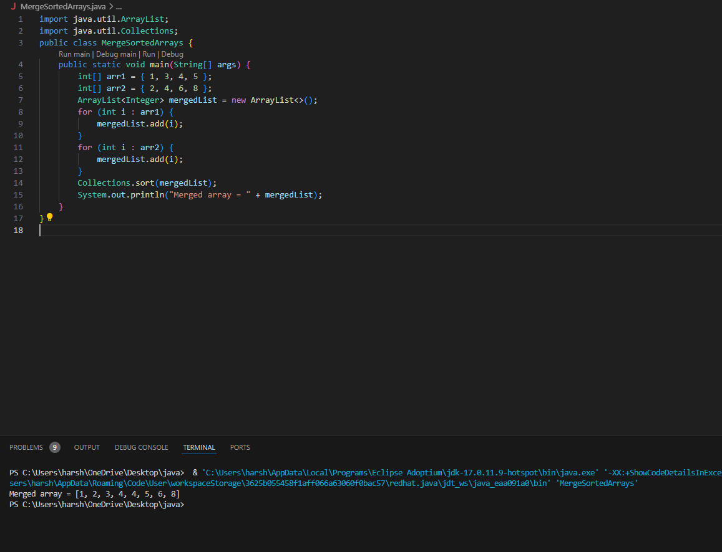

1. Find the Mean, Median, Mode of the array of numbers?

Sample Input;:

Array of elements = {16, 18, 27, 16, 23, 21, 19}

Sample Output:  
Mean = 20

Median = 19

Mode = 16

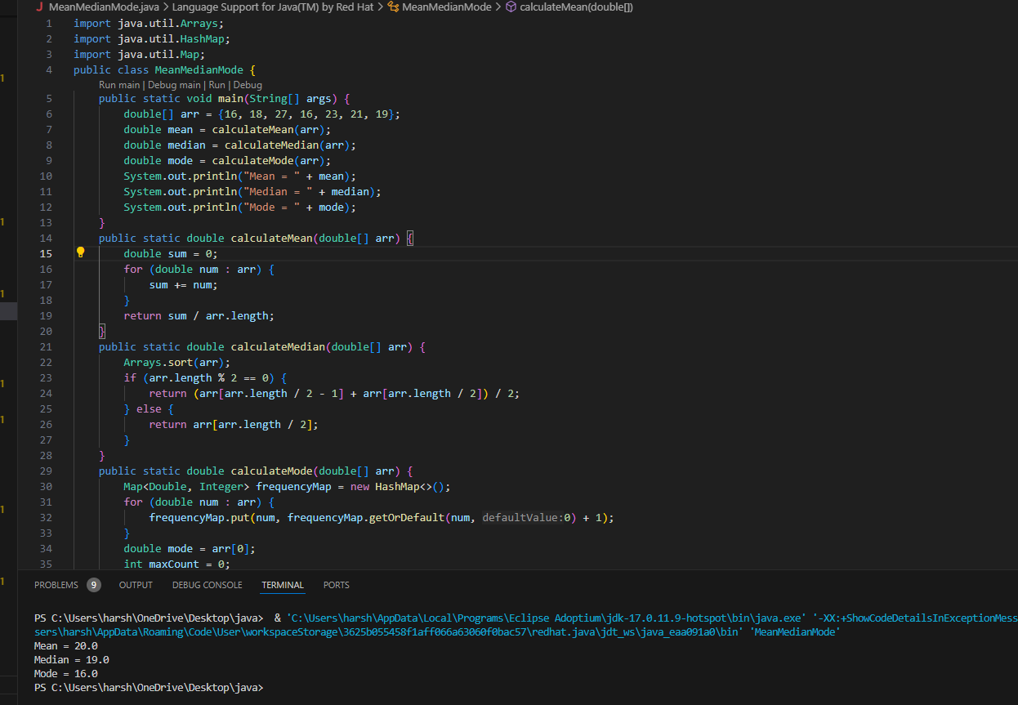

1. Write a program to find the number of composite numbers in an array of elements

Sample Input;:

Array of elements = {16, 18, 27, 16, 23, 21, 19}

Sample Output:  
Number of Composite Numbers = 5

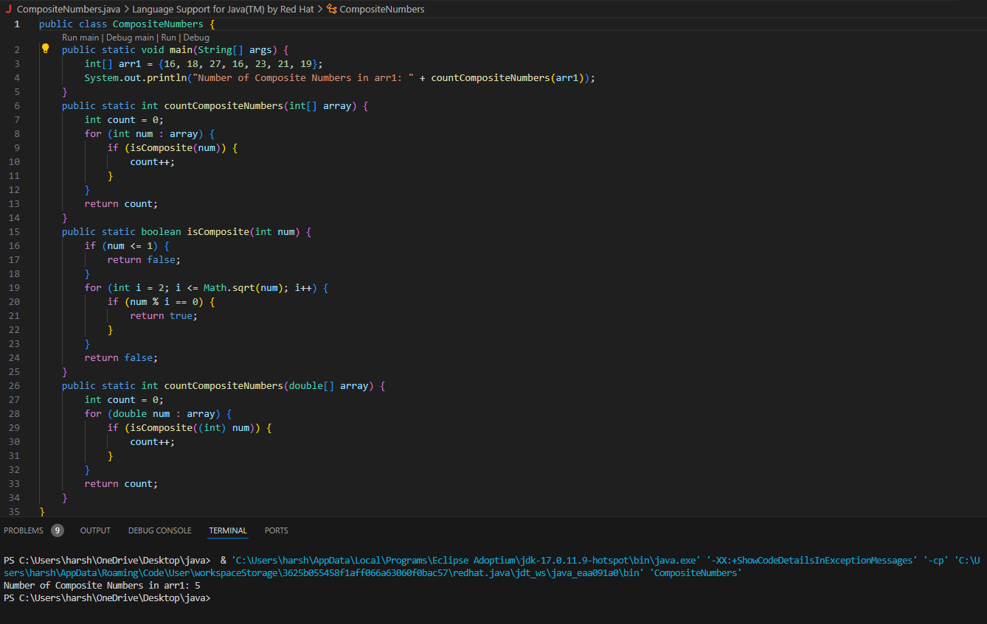

1. Write a program to print Right Triangle Star Pattern

Sample Input:: n = 5

Output:

*

* *

* * *

* * * *

* * * * *

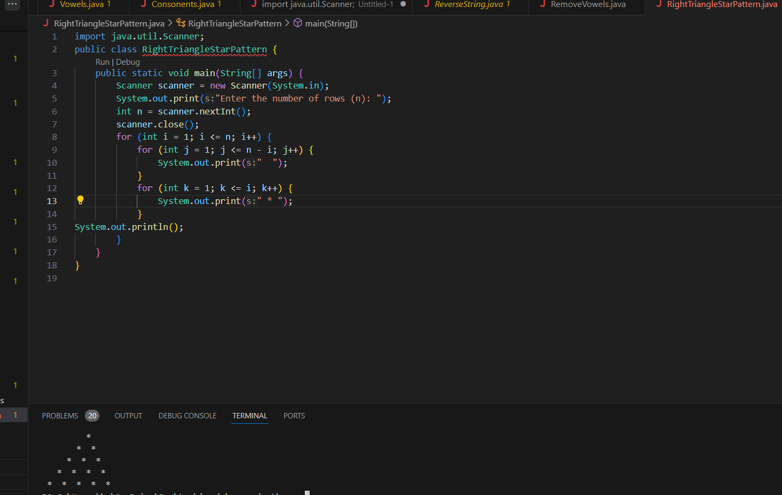

1. Write a program to print the below pattern?

|  |  |  |  |  |  |  |  |  |
| --- | --- | --- | --- | --- | --- | --- | --- | --- |
|  |  |  |  | 1 |  |  |  |  |
|  |  |  | 1 |  | 1 |  |  |  |
|  |  | 1 |  | 2 |  | 1 |  |  |
|  | 1 |  | 3 |  | 3 |  | 1 |  |
| 1 |  | 4 |  | 6 |  | 4 |  | 1 |

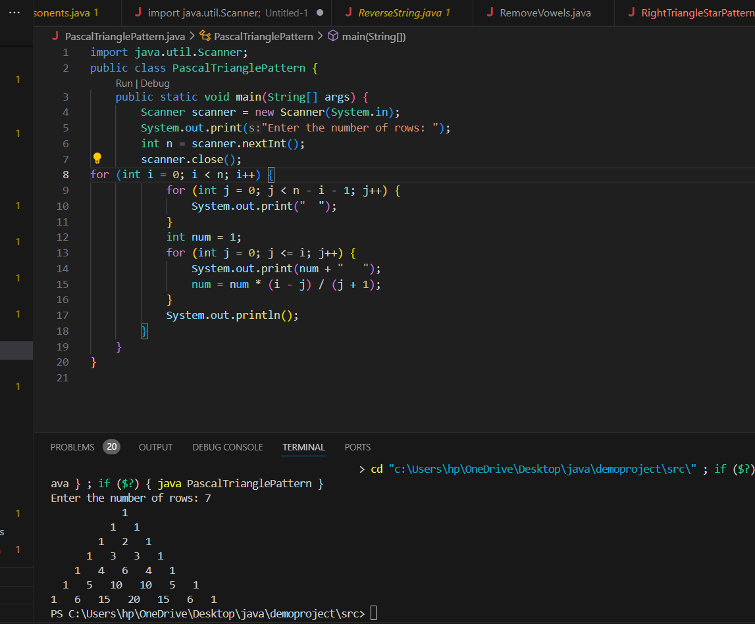

1. Write a program to print rectangle symbol pattern.

Get the symbol as input from user

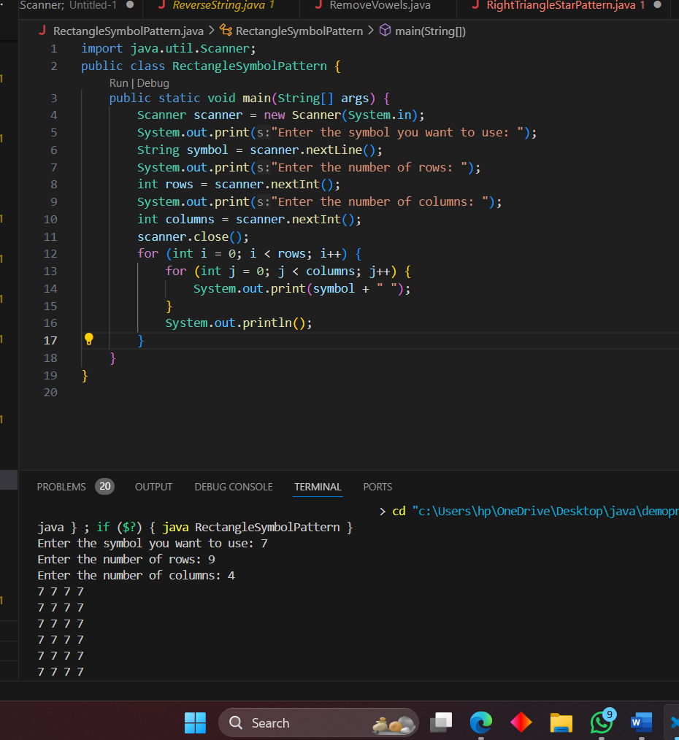

1. Write a program to print the following pattern

Sample Input:

Enter the number to be printed: 1

Max Number of time printed: 3

1

11

111

11

1

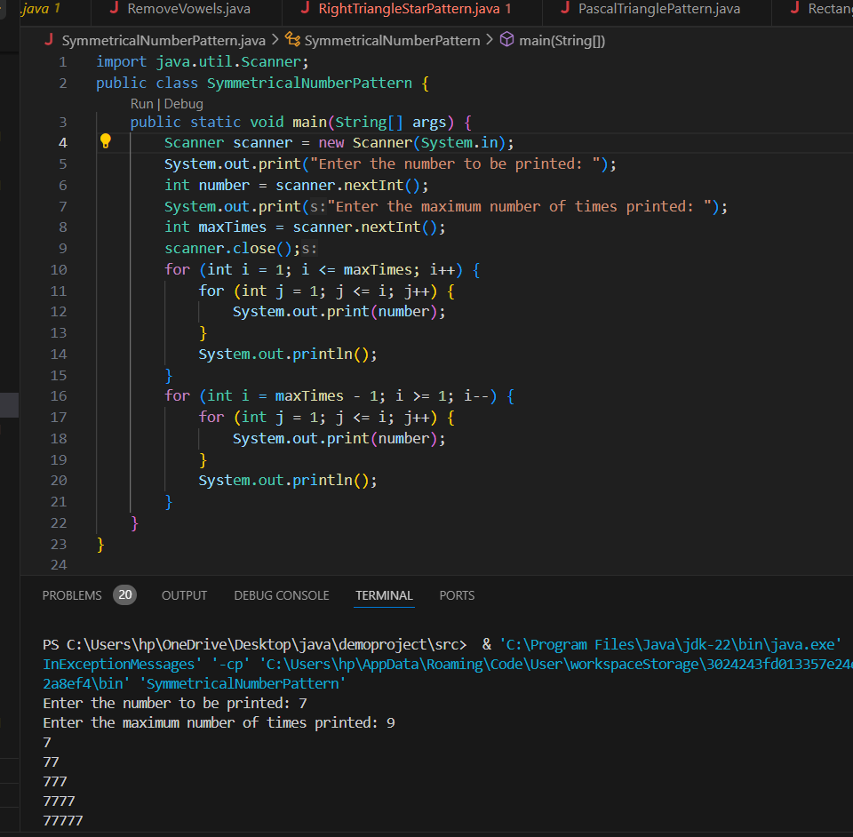

1. Write a program to print the Inverted Full Pyramid pattern?

